Snap!

心臟病

In this project you will make a simple version of the card game “Snap!” in Scratch.

在這個專案裡，你會製作一個簡單版的Scratch心臟病(Snap!)遊戲。

To have your move, you’ll take a photo of your card.

你要幫你的卡牌拍照來決定要做什麼動作。

But first, you’ll need to train the computer to look at your photos and recognise the different cards in your pack.

但在遊戲開始之前，你需要先訓練電腦辨識照片，看你手上有哪些不同的卡牌。

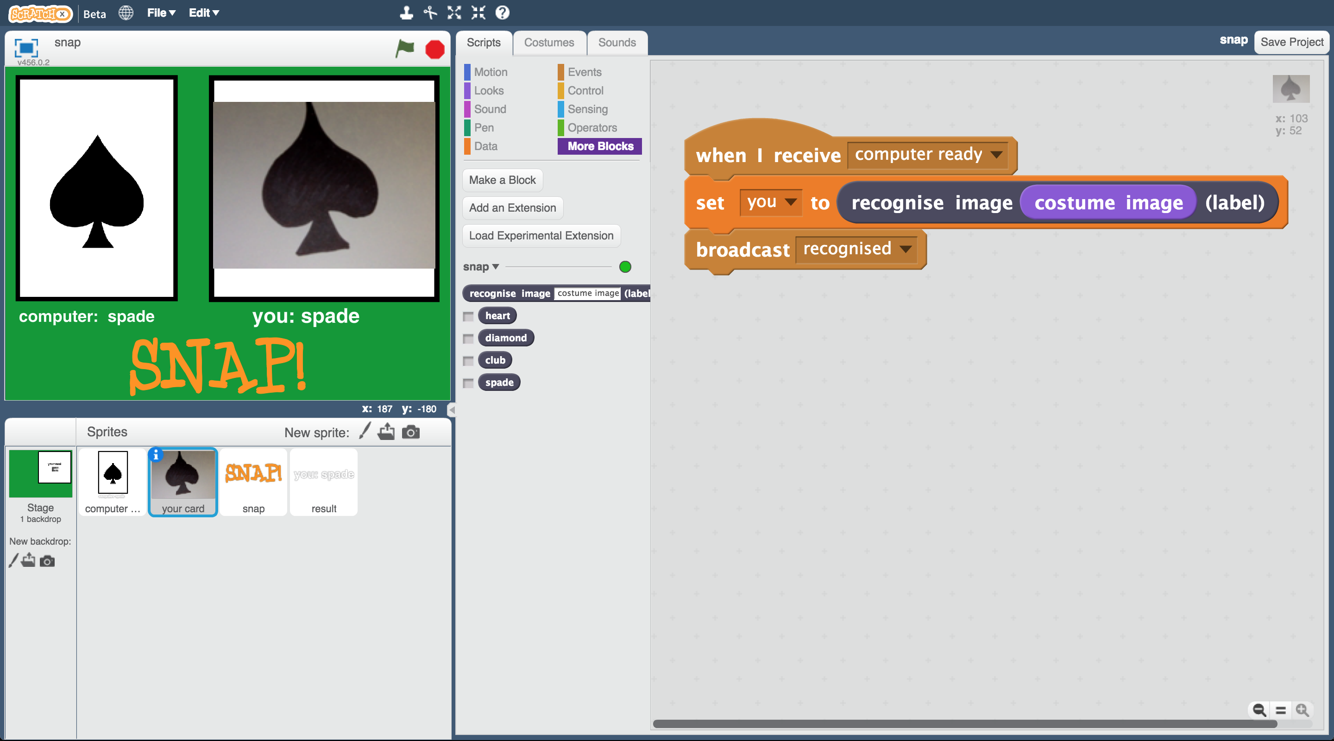

This project worksheet is licensed under a Creative Commons Attribution Non-Commercial Share-Alike License

http://creativecommons.org/licenses/by-nc-sa/4.0/

1. You’ll need four cards for this project  
   *Ask your group leader for a club, spade, heart and diamond.*

你需要四張卡片。

*跟你的老師/組長要黑桃、愛心、菱形、梅花的卡牌各一張。*

1. Go to <https://machinelearningforkids.co.uk/> in a web browser

搜尋網頁：<https://machinelearningforkids.co.uk/>

1. Click on “**Get started**”

點選“**Get started**”

1. Click on “**Log In**” and type in your username and password  
   *If you don’t have a username, ask your teacher to create one.  
   If you can’t remember your username or password, ask your teacher or group leader to reset it for you.*

點選“**Log In**”按鈕並登入系統

*如果你沒有帳號，請你的老師幫你建立一個帳號。*

*如果你不記得你的帳號或密碼，請你的老師幫你重新設定一次。*

1. Click on “**Projects**” on the top menu bar

點選上方清單中的 **”Projects”** 按鈕

1. Click the **“+ Add a new project**” button.

點選 “**+ Add a new project**” 按鈕

1. Name your project “snap” and set it to learn to recognise “**images**”.

將你的專案命名為 “snap”並設定成辨識 “**images**”類別  
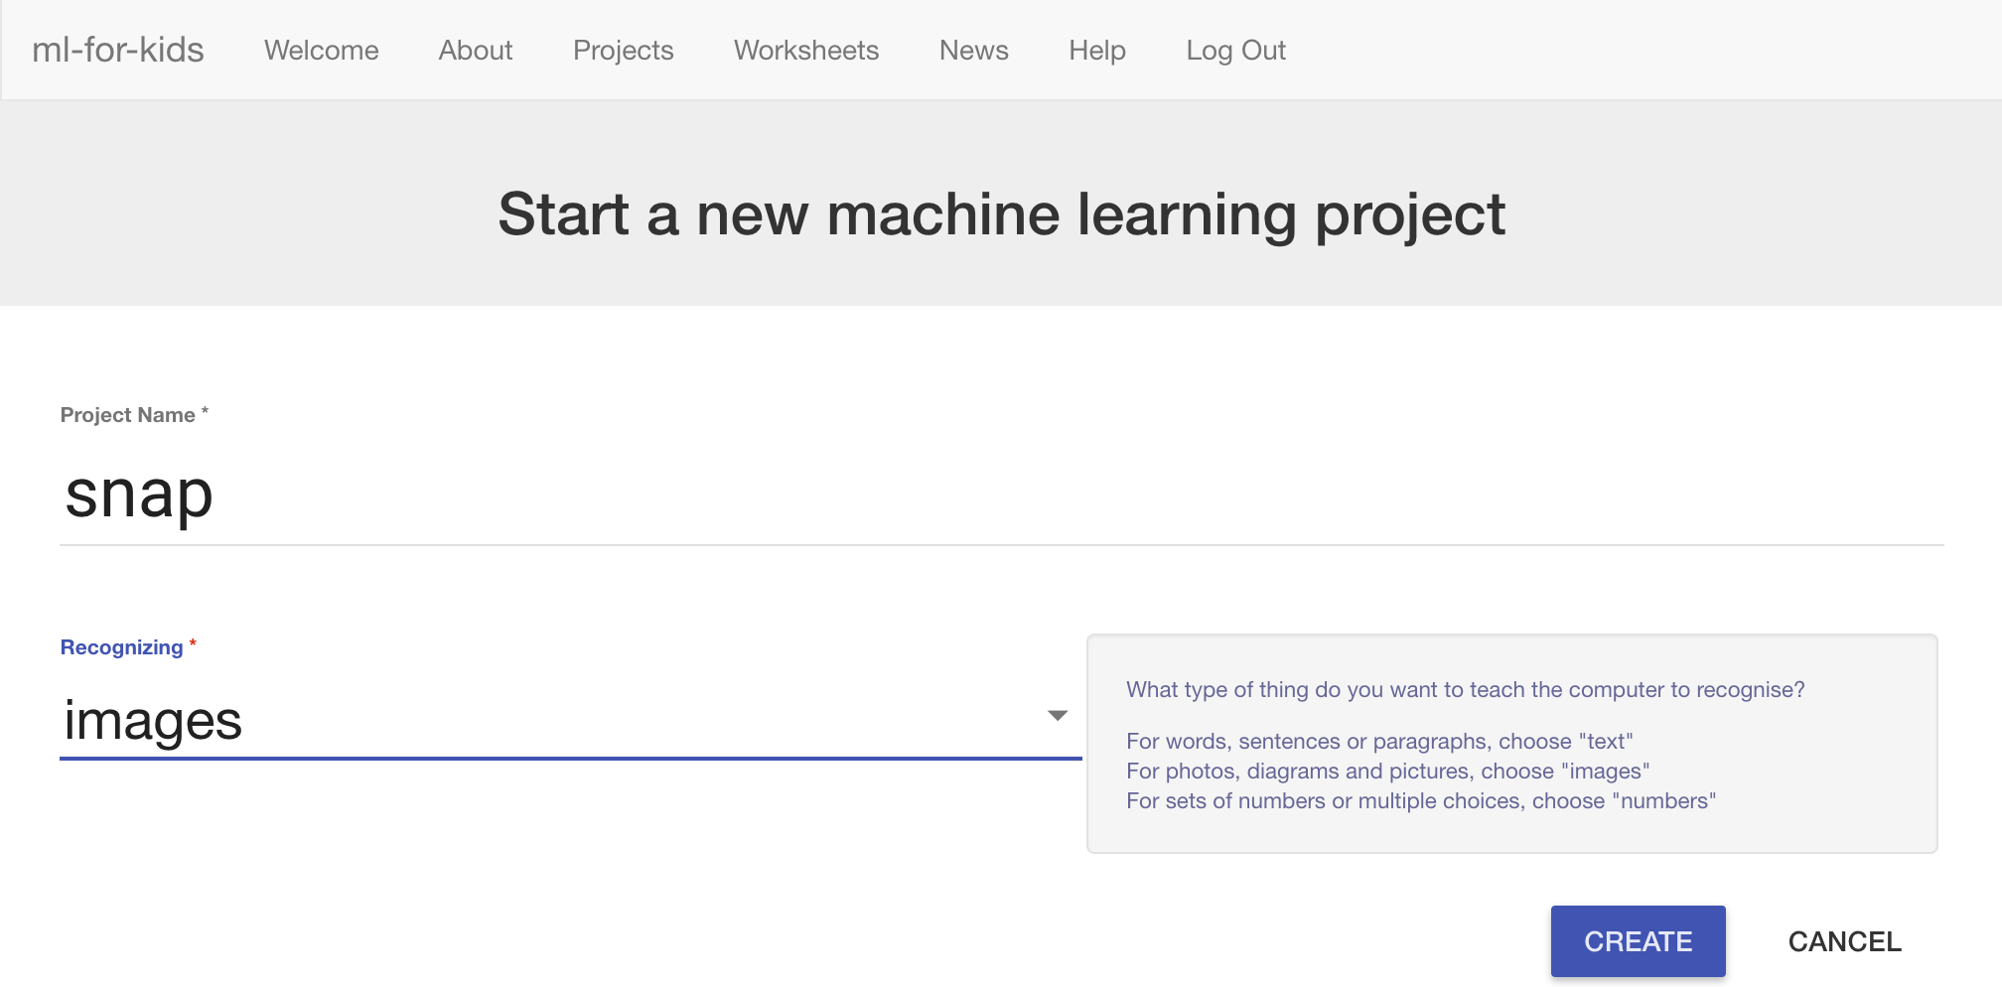

1. Click the “**Create**” button

點選 “**Create**”按鈕

1. You should see “snap” in the projects list. Click on it.

你會在專案清單中看到“**snap**”，點選此專案

1. Click on “**Train**”

點選 **”Train”** 按鈕  
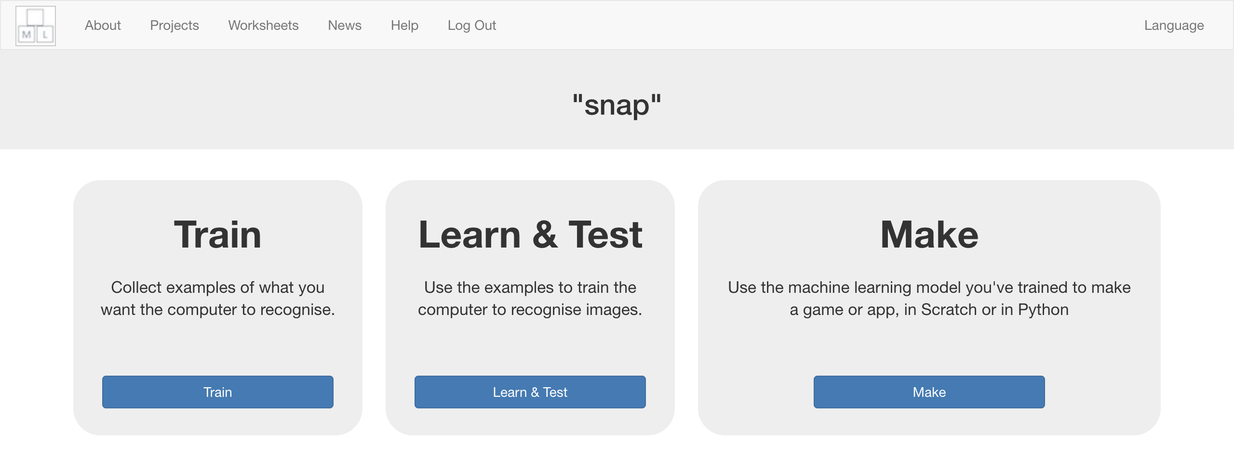

1. Click on “**+ Add new label**” and create a bucket called “heart”.

點選 “**+ Add new label**”按鈕，建立一個名為”heart”的方框  
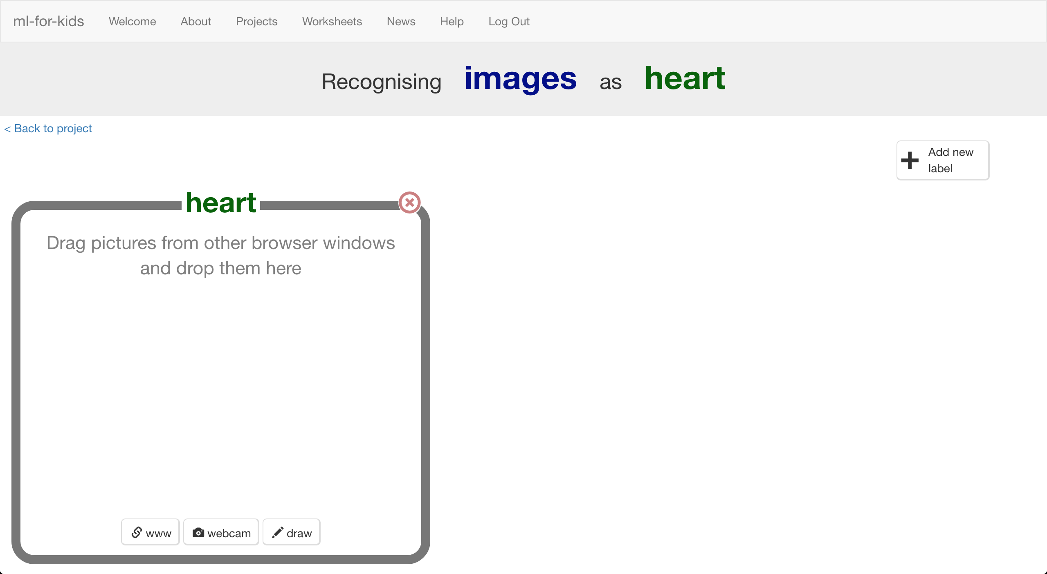

1. Click the “**webcam**” button  
   The Preview window shows the current view from your webcam.  
   *You will need to click “Approve” or “Allow” if your web browser asks permission to use your webcam.*

點選“**webcam**”按鈕，預覽視窗裡會顯示出目前你的鏡頭所拍到的畫面。

*如果你的瀏覽器要求存取權，點選『允許』*

1. Hold the Heart card to the webcam and click “**Add**” to take a photo

將愛心卡牌放到鏡頭前，點選“**Add**”拍張照片。 **

1. Repeat until you’ve taken **10 photos** of the Heart card

重複上個步驟直到至少有**10張**愛心卡牌的照片  
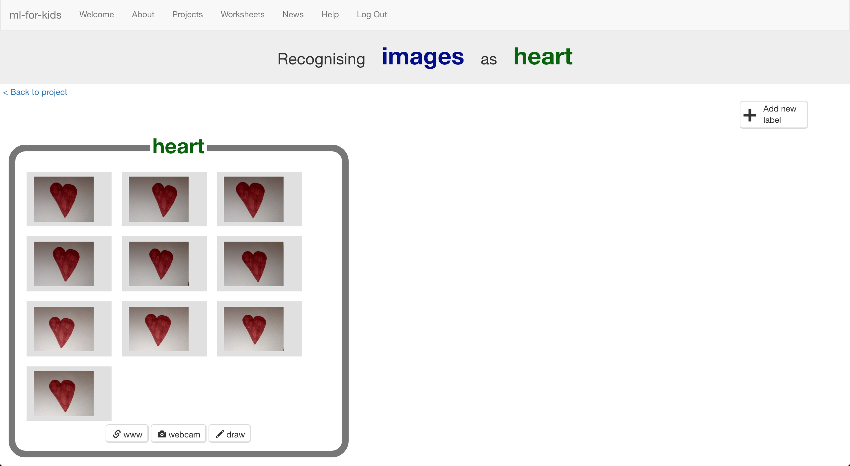

1. Click “**+ Add new label**” and create one called “diamond”

點選“**+ Add new label**”建立一個方框，命名為“diamond”

1. Use the “**webcam**” button in the “diamond” bucket to   
   take 10 photos of your Diamond card

點選“diamond”方框中的“**webcam**”按鈕，拍十張菱形卡牌的照片

1. Repeat for “club” and “spade”.

幫“club”和“spade”建立方框與拍照  
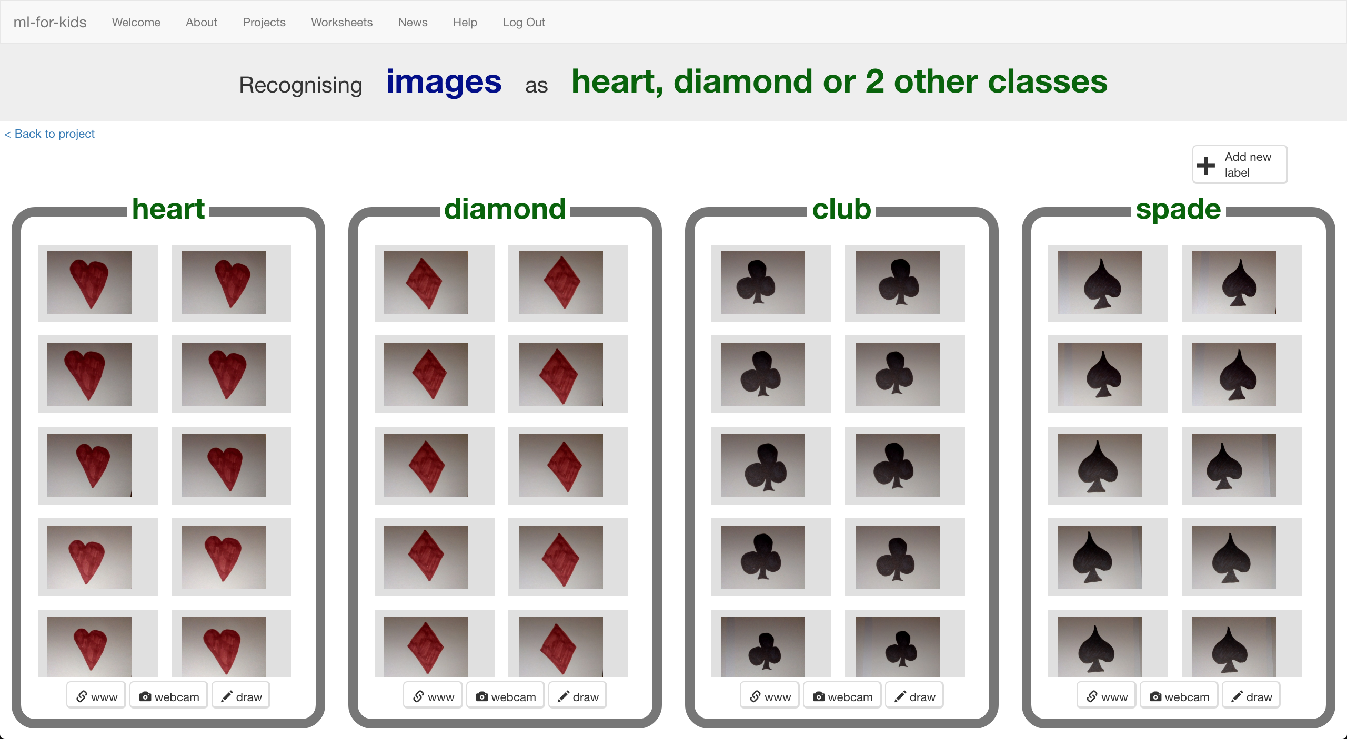

1. Click on the “**< Back to project**” link.

點選“**< Back to project**”

1. Click the “**Learn & Test**” button.

點選“**Learn & Test**”按鈕

1. Click the “**Train new machine learning model**” button.

點選“**Train new machine learning model**”按鈕  
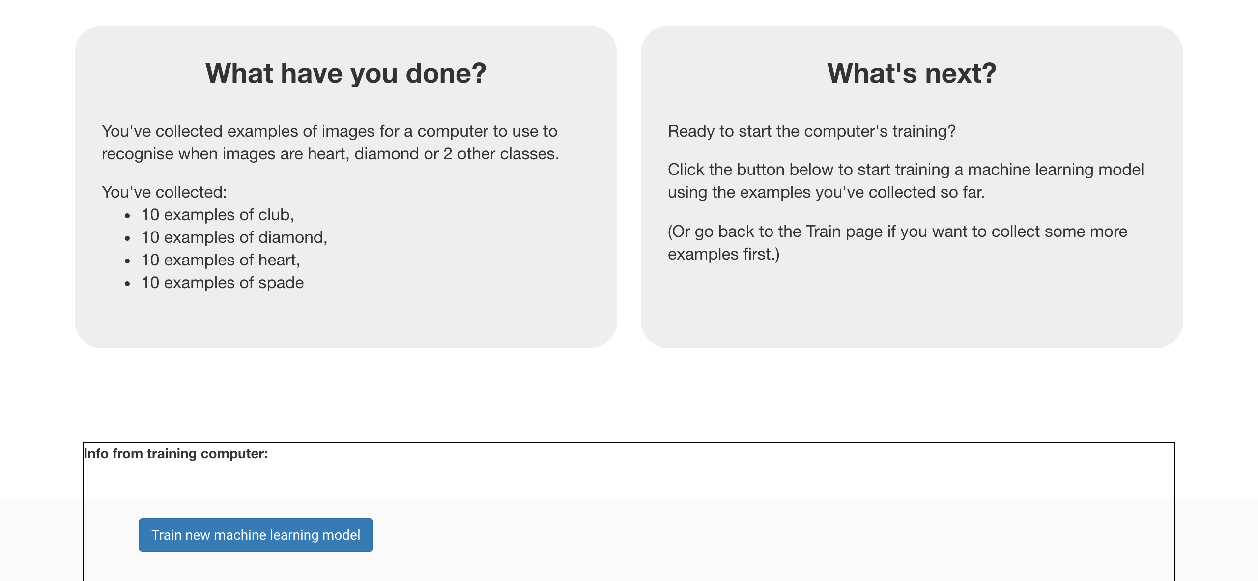

1. Wait for the training to complete. This might take a few minutes.  
   *While waiting, try to complete the machine-learning multi-choice quiz at the bottom of the page.*

等待訓練完成，*此步驟可能需要花費幾分鐘的時間*

**到目前為止，你做了哪些事情？**

**What have you done so far?**

You’ve started to train a computer to recognise cards as being heart, diamond, club or spades. You are doing it by collecting example photos. These examples are being used to train a machine learning “model”.

你蒐集範例照片來訓練電腦辨別不同花色的卡牌。這些範例會被用來訓練一個機器學習的 『模型』。

This is called “supervised learning” because of the way you are supervising the computer’s training.

這就是所謂的『監督式學習』，因為你在這個過程中確保（監督）電腦收到的結果是正確的 (supervised learning)。

The computer will learn from patterns in the colours and shapes from each of the photos you’ve given it. These will be used to be able to recognise new photos.

電腦會從範例照片的顏色與形狀學習到一些模式。這些東西會被用來辨識新的照片。

1. Click the **“< Back to project**” link

點選“**< Back to project**”

1. Click the “**Make**” button

點選“**Make**”按鈕

1. Click the “**Scratch**” button.

點選“**Scratch**”

1. Click “**Open in Scratch**”

點選**Open in Scratch**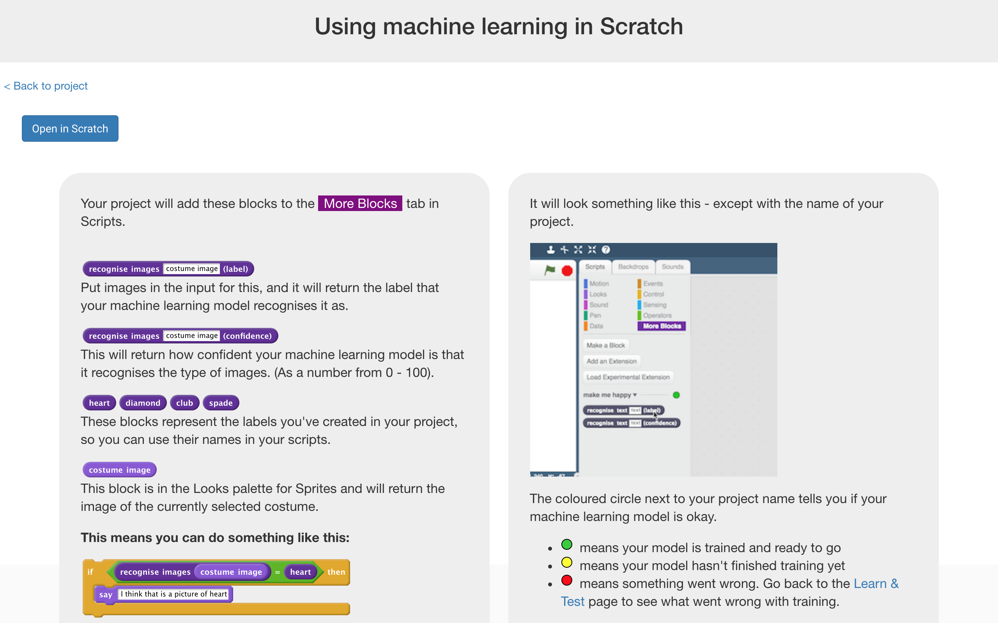

**小技巧**

**Tips**

**多一點範例！**

**More examples!**

當你給越多範例，電腦就應該能更正確的辨別卡牌的花色是黑桃、愛心、菱形或是梅花。

The more examples you give it, the better the computer should get at recognising whether a card is heart, diamond, club or spades.

**盡可能蒐集相同數量的照片**

**Try and be even**

嘗試讓各花色的範例照片一樣多

Try and come up with roughly the same number of examples for each shape.

如果你其中一種照片特別多，那麼電腦可能會更容易將照片判別成這一類，因此會影響到電腦的學習

If you have a lot of examples for one type, and not the other, the computer might learn that type is more likely, so you’ll affect the way that it learns to recognise photos.

1. *You should see new blocks in “More blocks” from your project.*

你可以在專案裡的『更多積木』(More blocks)區看到新積木  
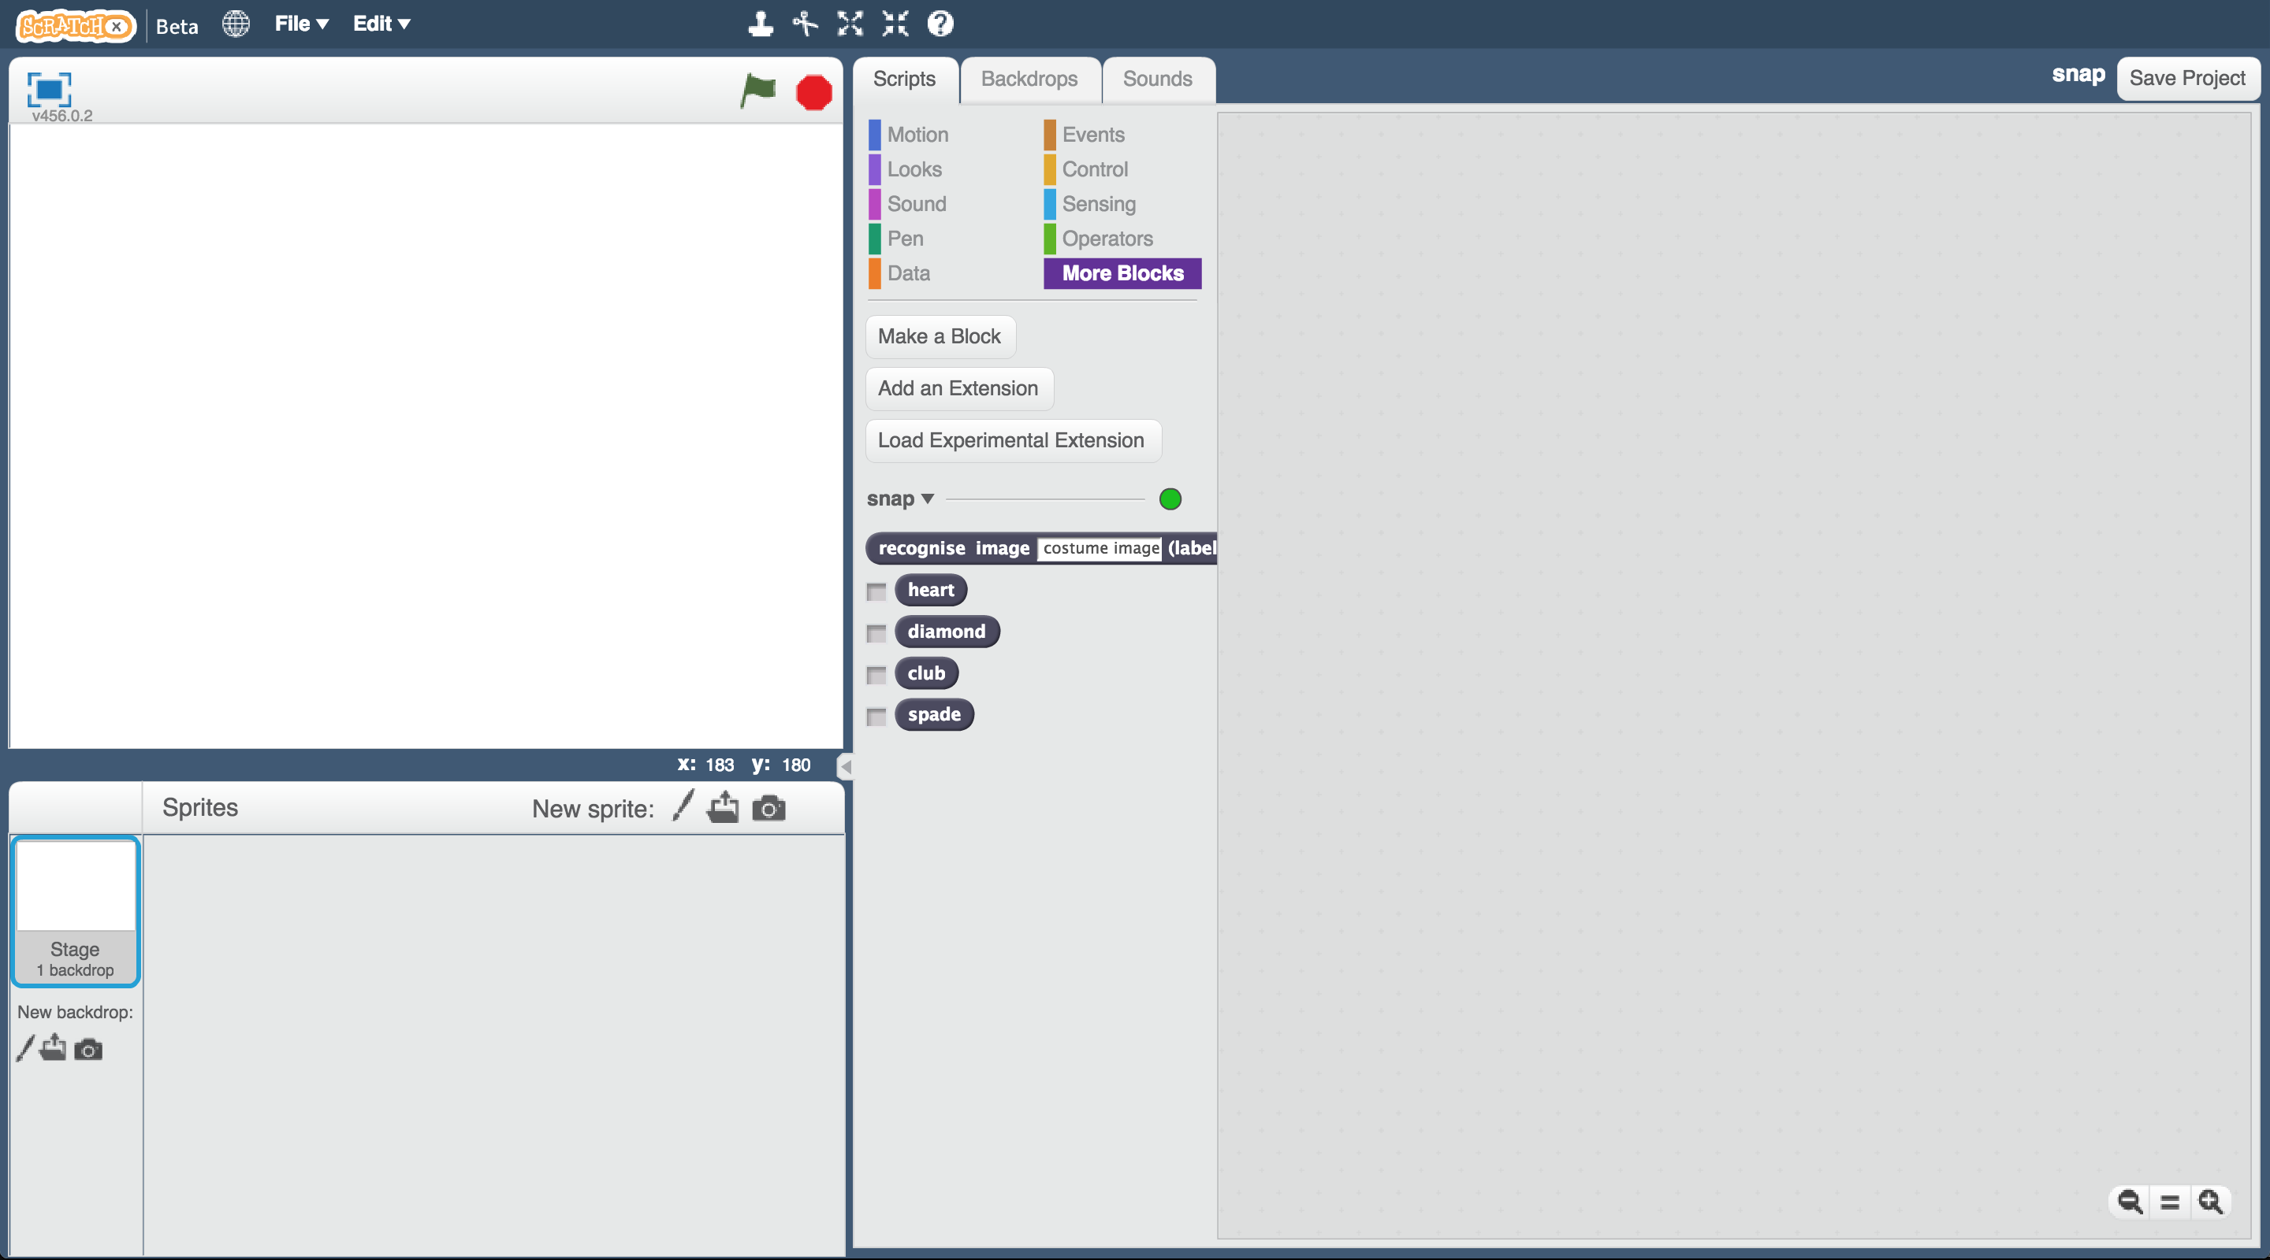

1. Open the **Snap** project template.   
   *Click* ***Project templates*** *->* ***Snap***

開啟**Snap**專案

*點選****Project templates，****再點選****Snap****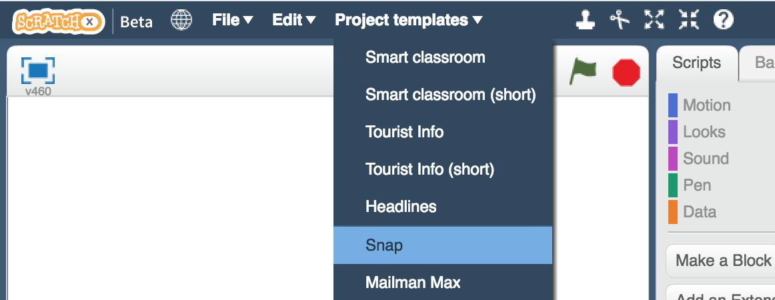*

1. Click on the “computer card” sprite

點選角色“computer card”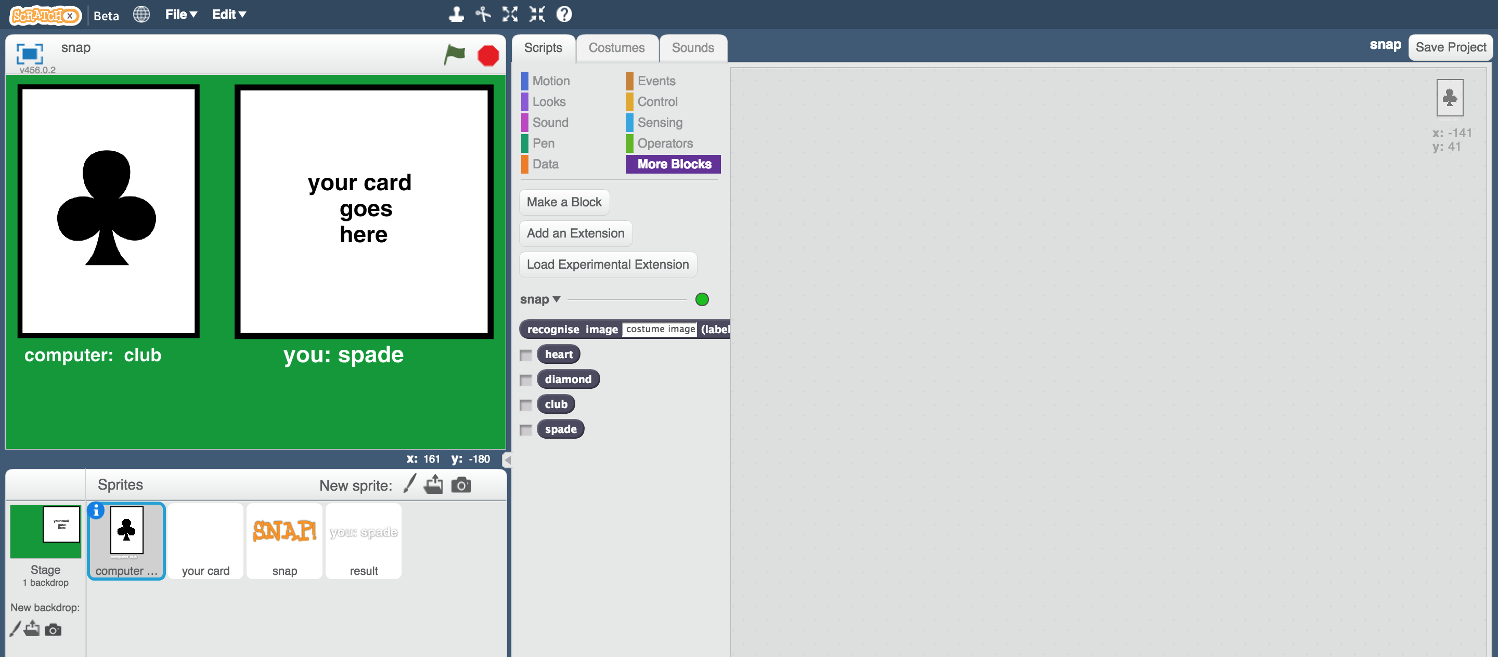

1. Create this script  
   *This script will let the computer pick a random card.*

拖曳程式積木（如下圖）

*這串程式的用途是讓電腦隨機選擇一張卡牌*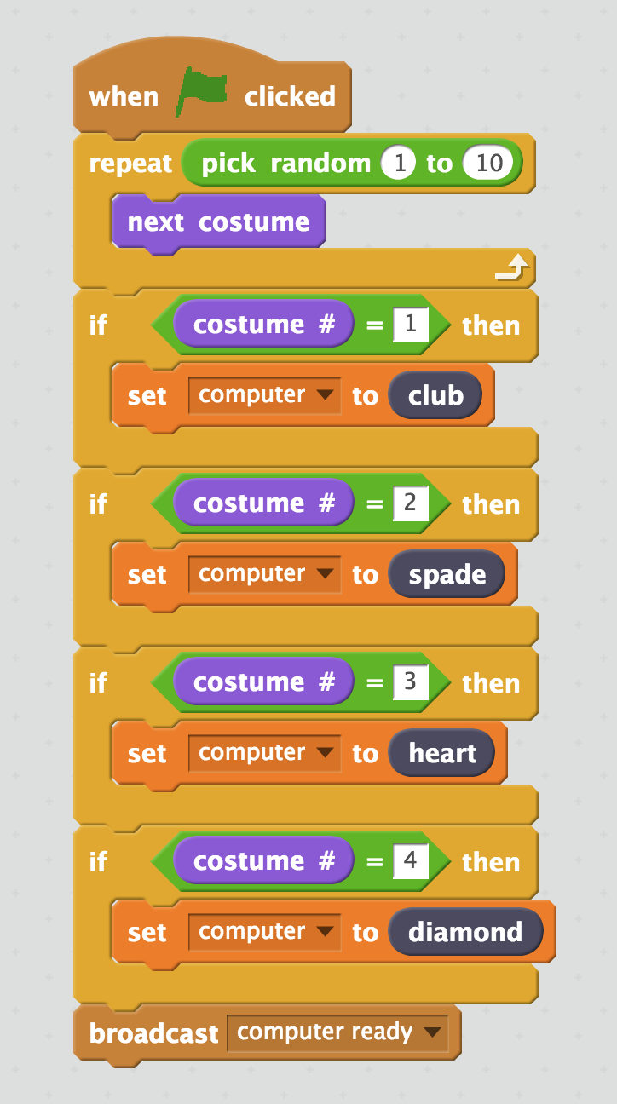

1. Click on the “your card” sprite

點選角色“your card”  
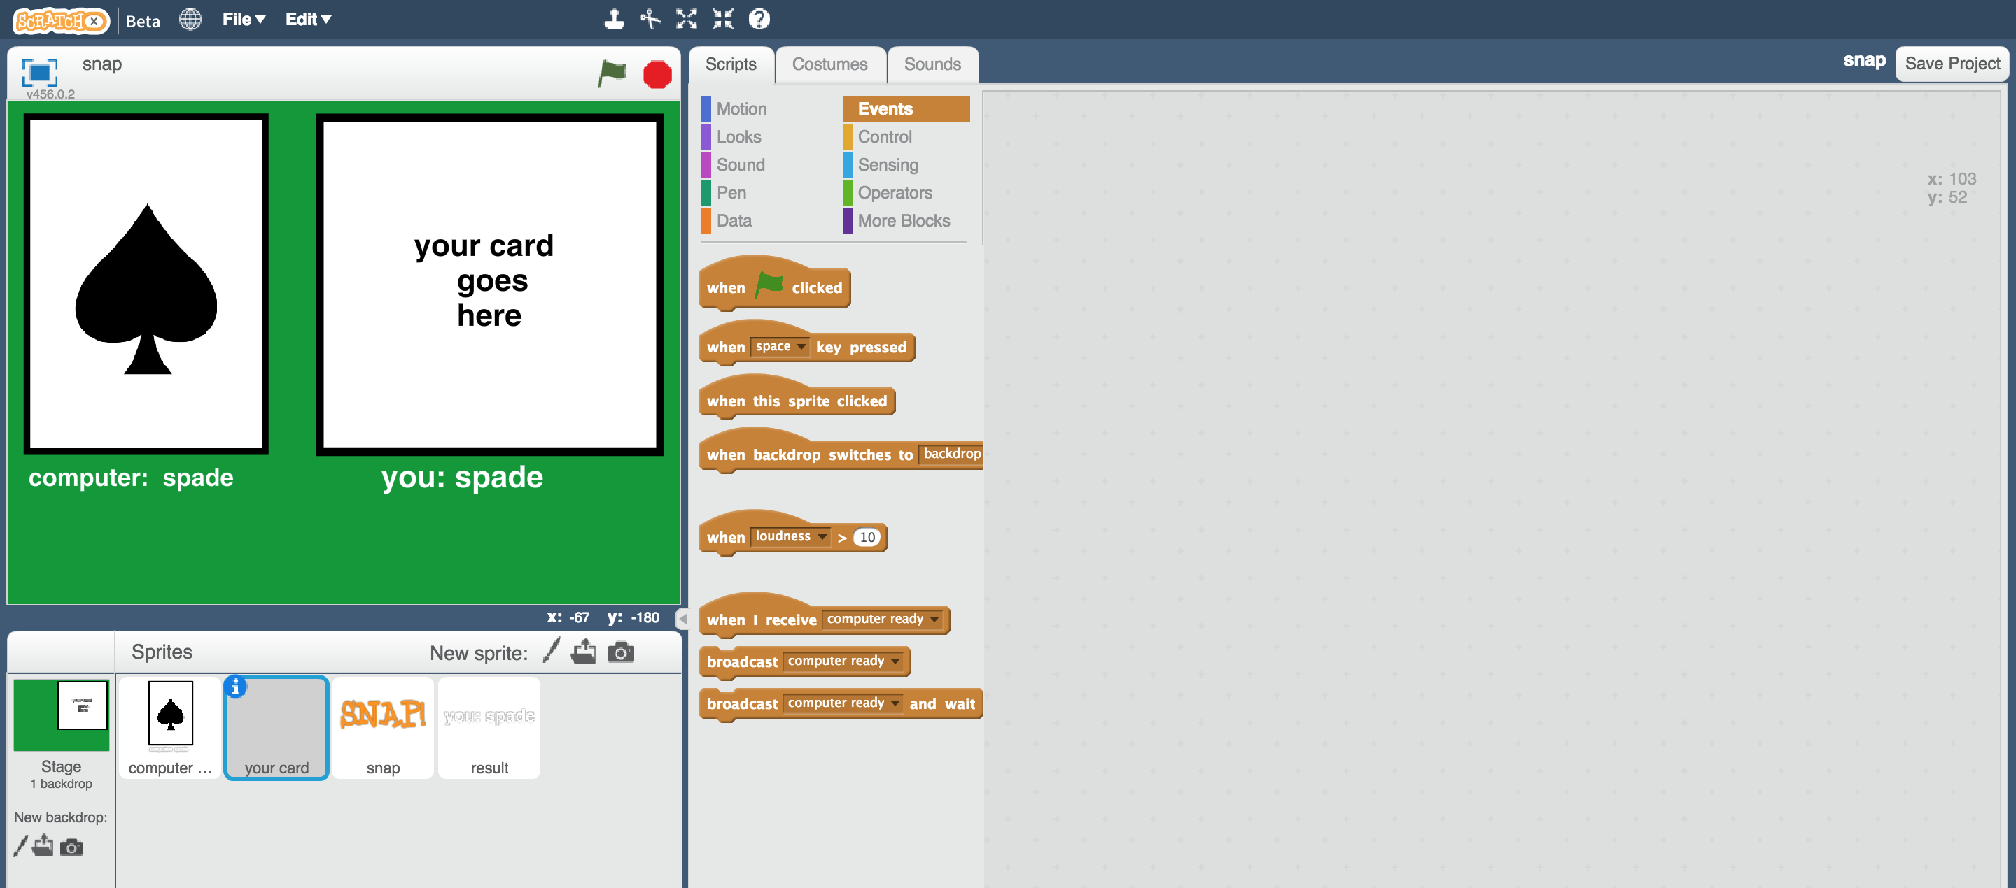

1. Create this script  
   *This script will let the computer recognise your card.*

拖曳程式積木（如下圖）

*這串程式的用途是讓電腦辨識你的卡牌*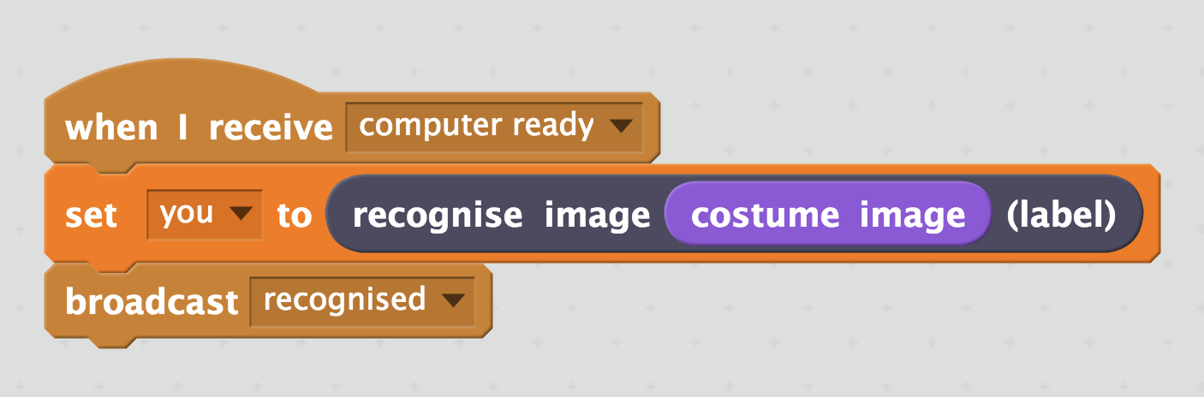

1. Click on the “snap” sprite

點選角色“snap”  
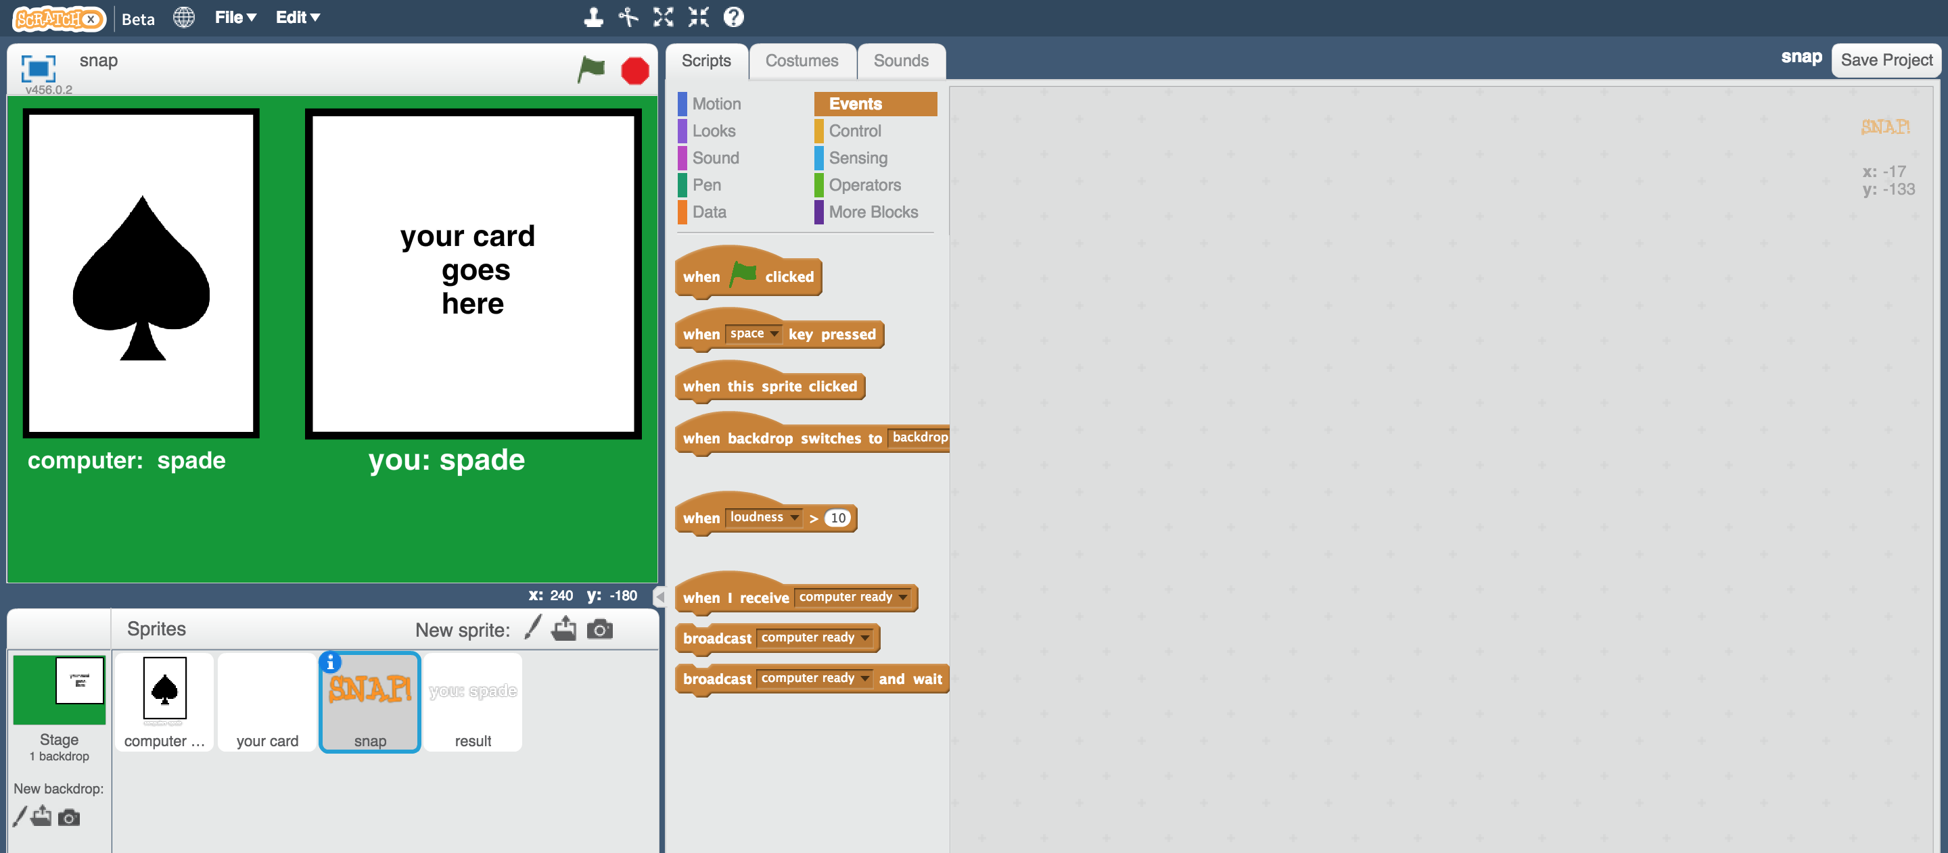

1. Create these scripts

拖曳程式積木（如下圖）

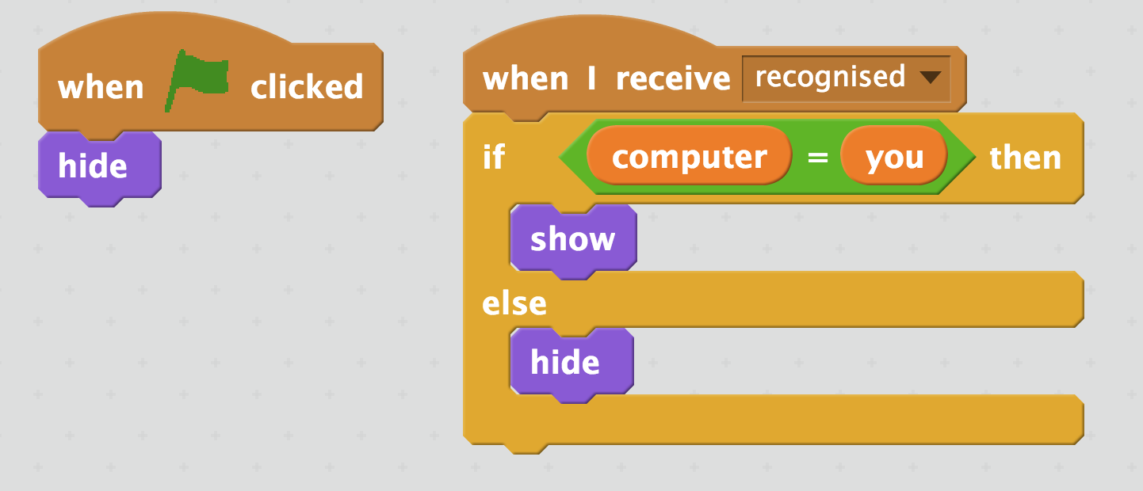

1. Click on the “result” sprite

點選角色“result”  
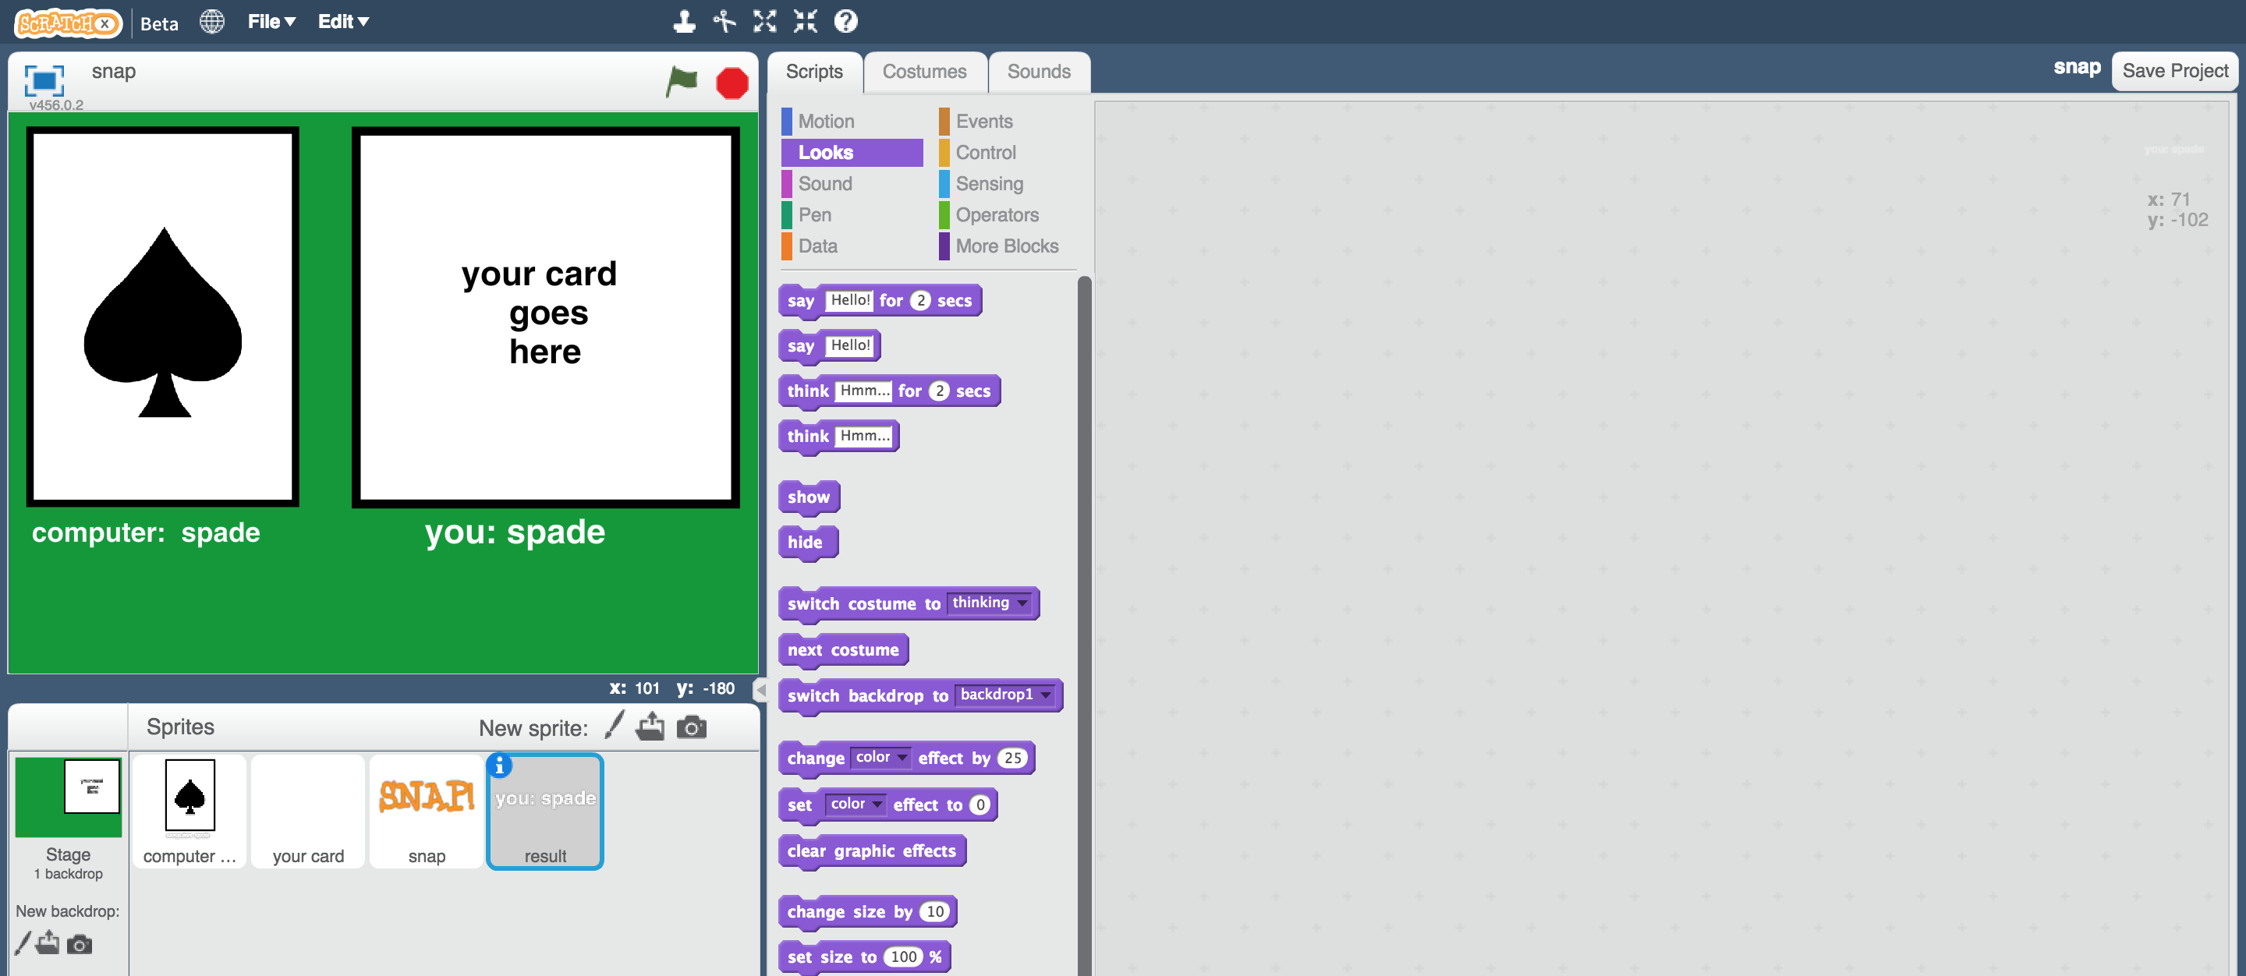

1. Create these scripts  
   *This script will display what the computer thinks your card looks like*

拖曳程式積木（如下圖）

*這些程式碼目的是在螢幕上顯示電腦猜測的卡牌花色*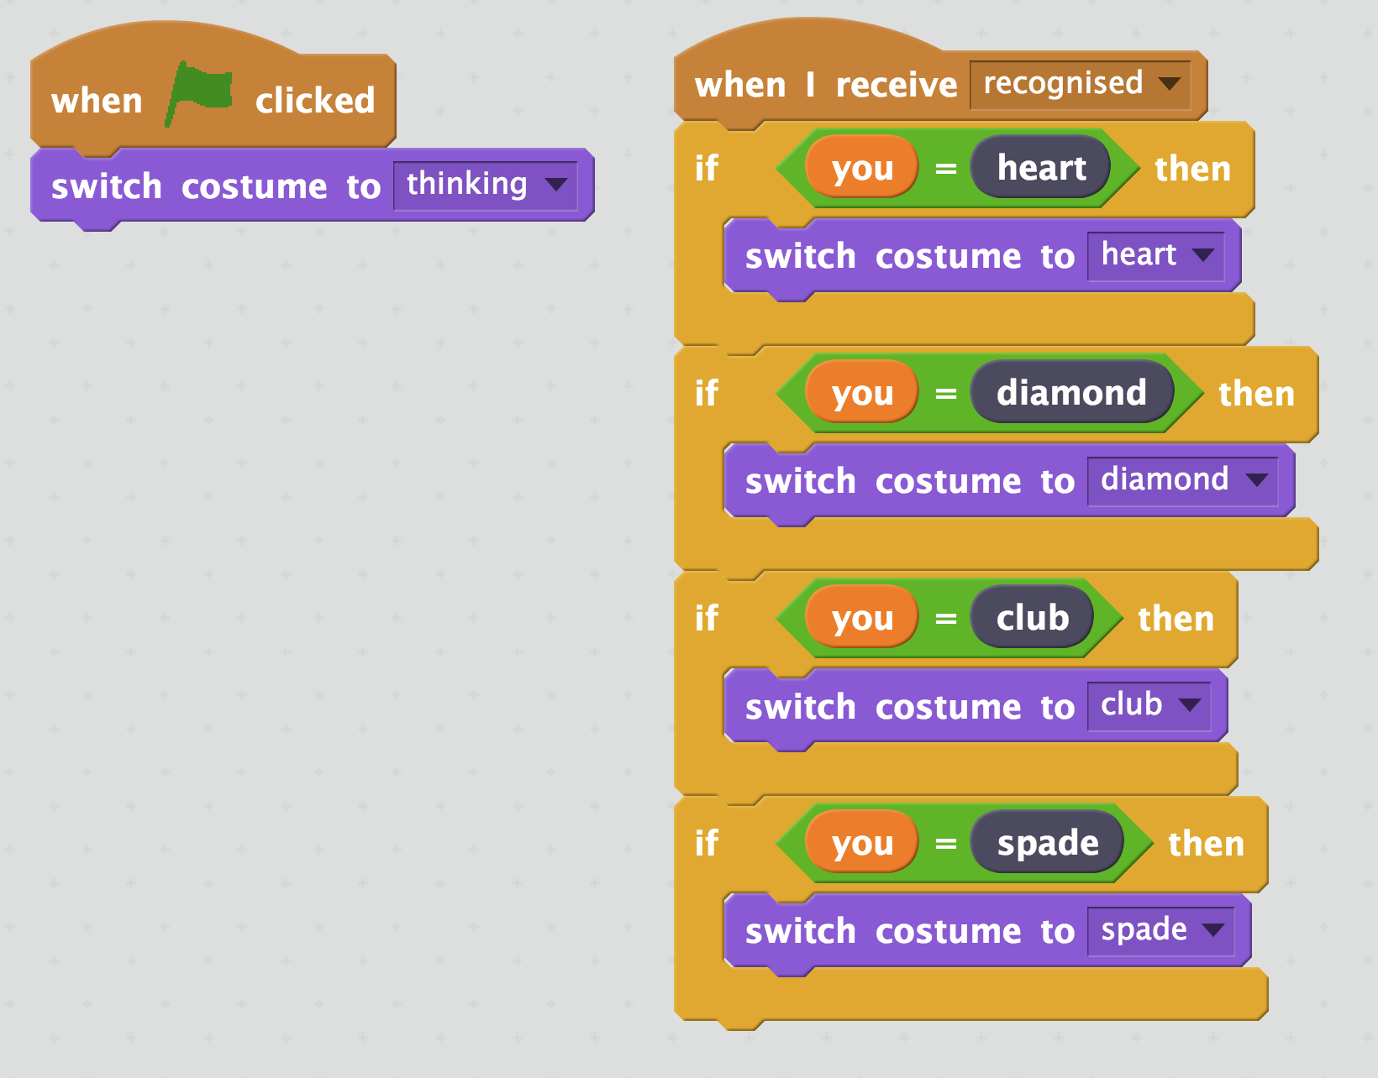

1. Save your project  
   *Click* ***File*** *->* ***Save Project***

存檔

*點選檔案，再點選儲存專案*

1. Shuffle your paper cards and pick one at random

將你手上的卡牌洗牌，並從中隨機選一張

1. Click on the “your card” sprite, then the costumes tab.   
   Click on the “**New costume from camera**” button

點選角色“your card”，點選『造型』，選擇『從攝影裝置錄製新造型』  
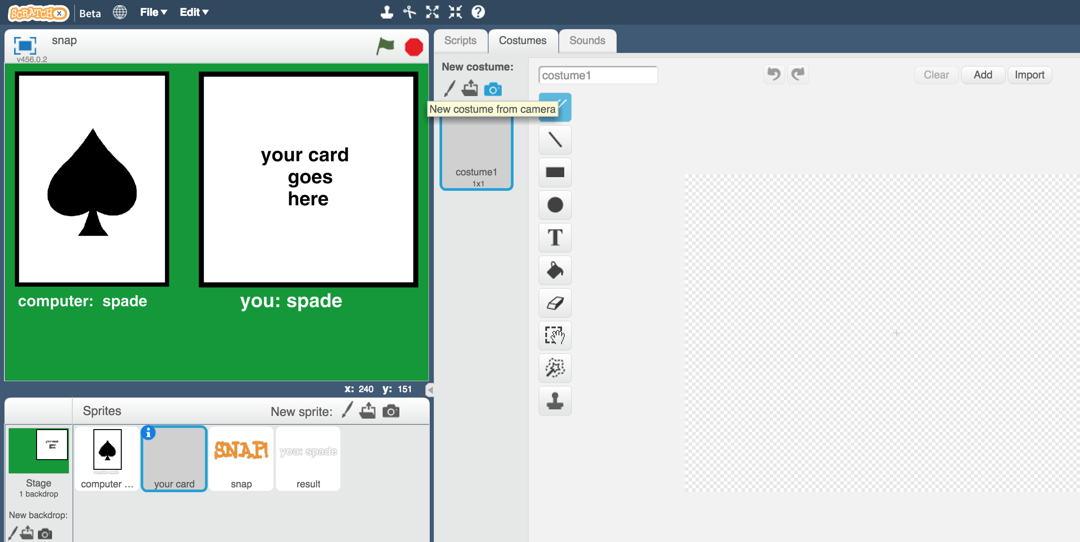

1. Use the webcam to take a photo of the card you picked  
   *Click Save when you’re ready to take the photo*

為你選出的卡牌拍張照  


1. Click the **Green Flag**

*The computer will choose a random card for its side.   
It will try to recognise your card, and if they match, it’ll display “SNAP!”*

點擊綠旗

*電腦會隨機挑張卡牌並嘗試辨認你的卡牌花色，如果是一樣的花色，螢幕會顯示“SNAP!”  
*

**你完成了什麼？**

**What have you done?**

你已經完成了一個簡單的Scratch卡牌遊戲。這遊戲使用攝影裝置拍攝你的卡牌，並用機器學習辨識照片中的卡牌花色。

You’ve made a simple card game in Scratch. The game uses a webcam to take pictures of your card, and uses machine learning to recognise the card in the photo.

這是『影像辨識』-教電腦辨別影像

This is “image recognition” – teaching a computer to recognise images.

**延伸活動**

**Ideas and Extensions**

現在你已經完成了這個專案，要不要試試下面的點子？或者，自己想一個？

Now that you’ve finished, why not give one of these ideas a try?

Or come up with one of your own?

**設計你自己的卡牌**

**Design your own cards**

除了黑桃、愛心、菱形和梅花外，要不要試著設計屬於你自己的卡牌？

Instead of hearts, spades, clubs and diamonds, why not make your own cards?

**大聲喊出“snap!”**

**Shout “snap!”**

除了只在螢幕顯示“SNAP!”，試試看錄製你自己喊“Snap!”的聲音，並更新Scratch專案，在卡牌配對時播放。

Instead of just displaying “SNAP!” can you record yourself shouting “Snap!” and get your Scratch project to play that when the cards match?

**競賽版遊戲**

**Make the game competitive**

修改遊戲，讓螢幕一開始不顯示電腦挑的卡牌，變成在辨識你的卡牌時同時顯示。

誰可以比較快喊出“snap”？是你嗎？還是電腦？

Modify the game so it doesn’t display the computer’s card at first. Let it display the card at the same time it starts to recognise yours.

Who is quicker at saying “snap”? You or the computer?